Chinese Restaurant Website

Detailed Project description

This website is proposed to serve customers to order online in a Chinese restaurant in which several ordering modules and webpages are implemented. In the website, the customer can see a function list:

* Homepage
* Menu
* Reservation
* Order History
* Sign up
* Log In

When a customer visits our website for the first time, users can see the homepage with main function links and pictures shows or announcements, users can register an account then log in the website, users will be able to order in the menu page, then an order list will be placed in the order history page. In addition, users also could make a reservation by choosing a date in the reservation page. We use html/CSS, jQuery, Java Script, Ajax, PHP, MySQL to build the website.

List of implemented functionalities and their implementation details and screenshots

**The main website**

In the main website, the customer can see a function list (Home, Menu, Reservation, Order History, Sign up and Log In), and some picture shows.

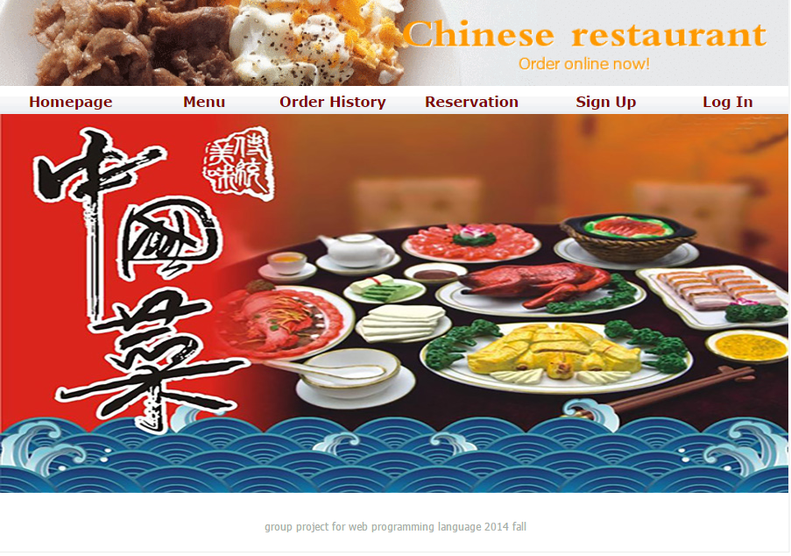

**Add a new customer to the system.**

The customer click the sign up button and fill the requirements (name, phone number, address, email, and password) to create a new customer account. Insert username , password and other user information into database with PHP Mysql, when user does not fill all field, the PHP page will prompt user to fill all fields, user should input password twice ,when two password is not same, PHP will prompts user to input again. There is also jQuery function to check user’s email whether is valid. Display a confirmation message: “Register successfully” after validation.

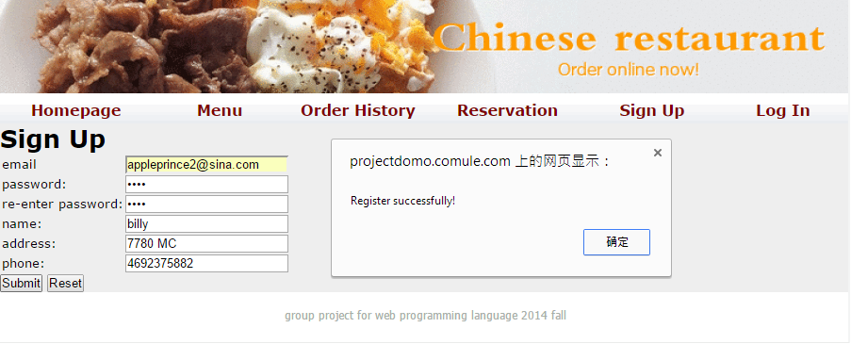

**Customer logins to the system use username and password and logout**

Users can login by inputting email and password, the account details will show on the on the top left of the page after login successfully, users can logout by clicking the logout under the account. PHP get username and password in Session, then then compare with the username and password in database.

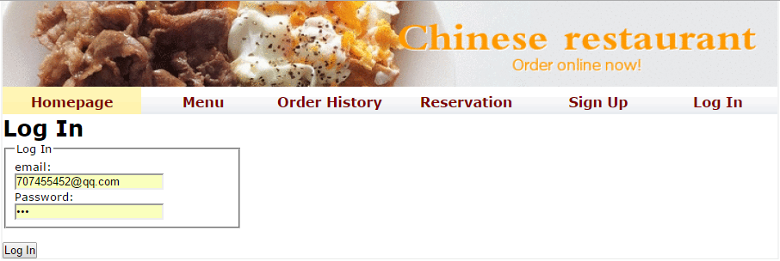

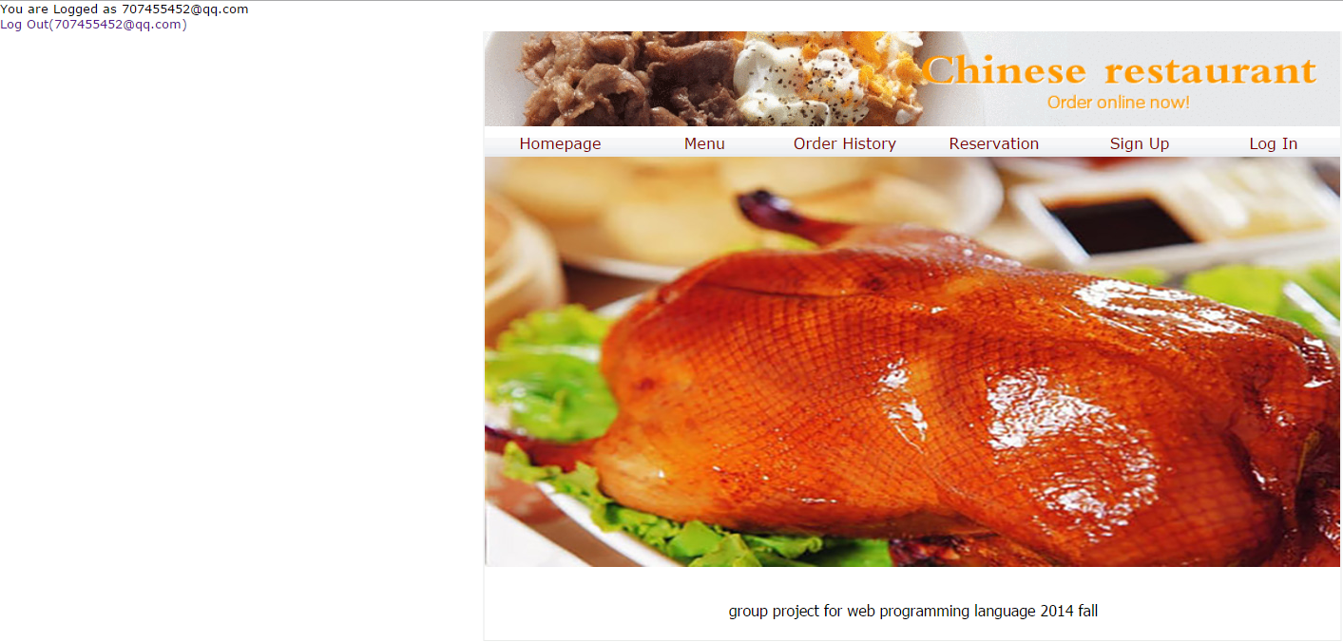

**Reservation**

The customer can choose the date to make a reservation.

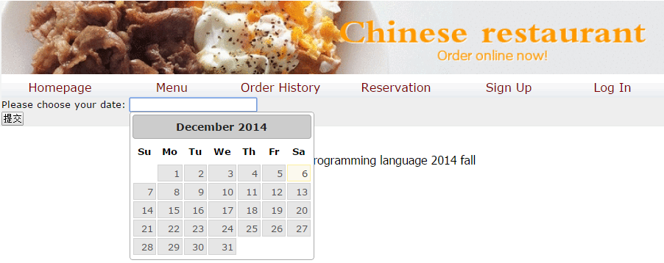

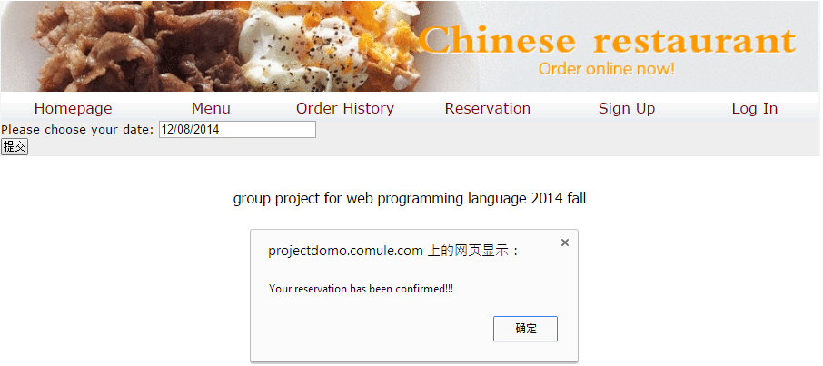

**The existing customer will see the menu.**

The menu could be shown in several categories (APPETIZERS, SOUP, LO MEIN OR FRIED RICE, SALAD, SIGNTURE, TRADITIONAL, ASIAN FUSIONS, DESIGN YOUR OWN DISH, DRINKS, SENIORS AND KIDS, DESSERTS, EXTRAS).

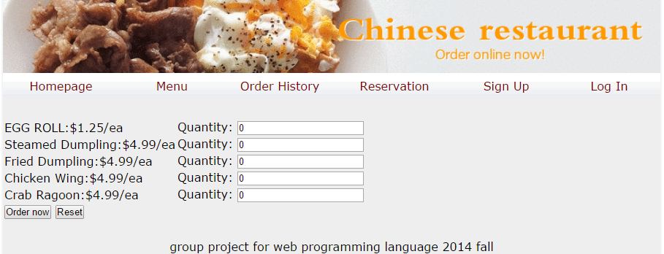

**User will be able to see the history of his orders.**

The customer can see the date and details of previous order. PHP fetch username from Session. And select records in table in database with the username, then echo the data in web page.

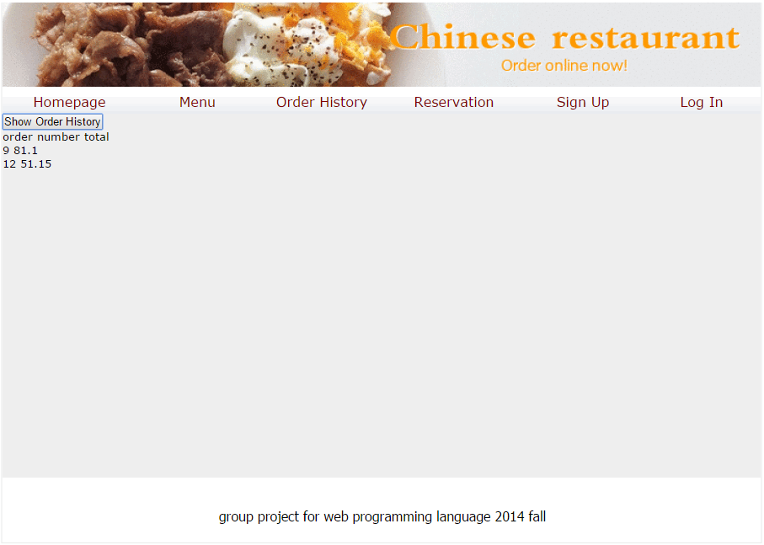

Relational database schema

* + ER diagram

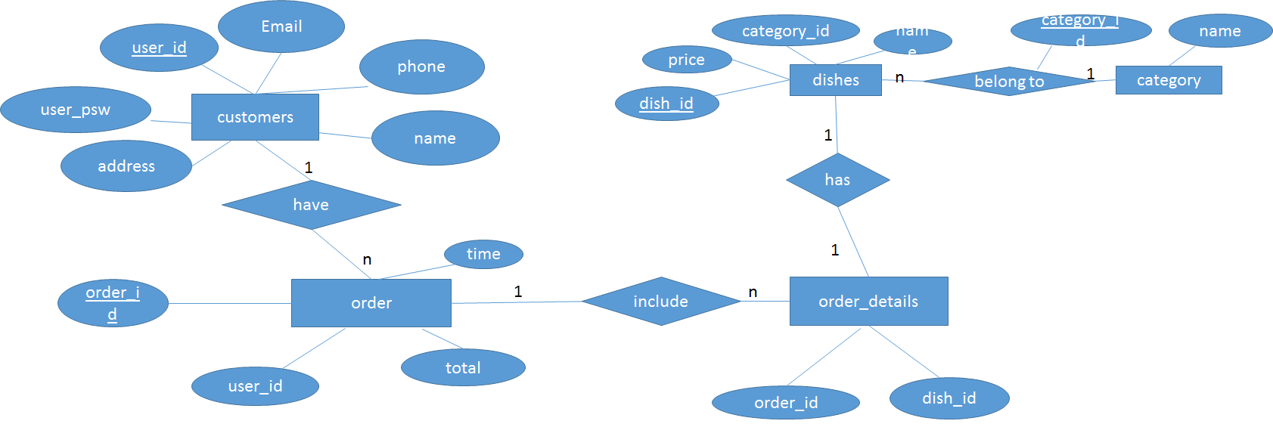

* + CREATE TABLE statements

CREATE TABLE IF NOT EXISTS `CUSTOMERS` (

`user_id` varchar(25) NOT NULL,

` user_psw` varchar(25) NOT NULL,

`name` varchar(25) NOT NULL,

`address` varchar(25) NOT NULL,

`phone` int(10) NOT NULL,

`email` varchar(50) NOT NULL

)

CREATE TABLE IF NOT EXISTS `DISHES` (

`name` varchar(25) NOT NULL,

`category_id` int(2) NOT NULL,

`price` double NOT NULL,

`dish_id` int(3) NOT NULL

)

CREATE TABLE IF NOT EXISTS `ORDERS` (

`order_id` varchar(25) NOT NULL,

`user_id` varchar(25) NOT NULL,

`time` datetime NOT NULL DEFAULT CURRENT_TIMESTAMP,

`total_amount` double NOT NULL,

)

CREATE TABLE IF NOT EXISTS `ORDER_DETAILS` (

`order_id` varchar(25) NOT NULL,

`dish_id` int(3) NOT NULL,

`quantity` int(3) NOT NULL

)

CREATE TABLE IF NOT EXISTS `CATEGORY` (

`category_id` int(2) NOT NULL,

`category_name` varchar(25) NOT NULL

)

ALTER TABLE `DISHES`

ADD PRIMARY KEY (`dish_id`), ADD KEY `fk_dishes` (`category_id`);

ALTER TABLE `ORDERS`

ADD PRIMARY KEY (`order_id`), ADD KEY `user_id_2` (`user_id`);

ALTER TABLE `ORDER_DETAILS`

ADD PRIMARY KEY (`order_id`,`dish_id`), ADD KEY `fk2_order_details` (`dish_id`);

ALTER TABLE `DISHES`

ADD CONSTRAINT `fk_dishes` FOREIGN KEY (`category_id`) REFERENCES `CATEGORY` (`category_id`);

ALTER TABLE `ORDERS`

ADD CONSTRAINT `fk_orders` FOREIGN KEY (`user_id`) REFERENCES `CUSTOMERS` (`user_id`);

ALTER TABLE `ORDER_DETAILS`

ADD CONSTRAINT `fk2_order_details` FOREIGN KEY (`dish_id`) REFERENCES `DISHES` (`dish_id`),

ADD CONSTRAINT `fk_order_details` FOREIGN KEY (`order_id`) REFERENCES `ORDERS` (`order_id`);